

Mawlana Bhashani Science and Technology University

Department of Computer Science & Engineering

**Sudoku Game**

Project Proposal

**Course Title :** Software Development Project-1 & Indusrial tour

**Course Code :** CSE2112

**Submitted By :**Md.Riazul Islam

ID. CE-14047

**Submitted To :** Md. Mahfuz Reza ,

Assistant Professor ,

Dept. of CSE, MBSTU.

**Date of Submission : 7.12.2015**

**Project Type :** Game.

**Project Name : Sudoku game.**

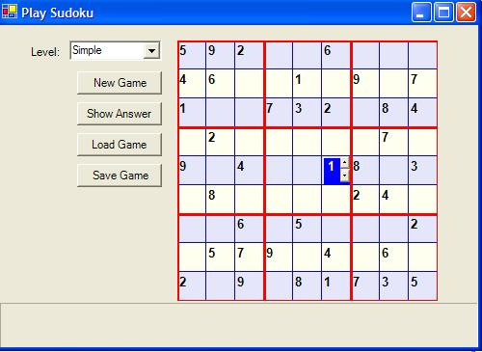

**Introduction :** I came across the Sudoku game a few months back. I commute daily to my university; this puzzle, in everyday newspaper, was one of my favorite ways to pass time in the university. I thought why not develop this game in C? This article is on the implementation of this game in C. The game provides three complexity levels: simple, medium and complex. The user can view the answer for a few seconds to get a clue. I hope you will enjoy playing this game. You require .NET Framework installed on your PC or laptop to run this program.

**Rules of Sudoku:** The game has simple rules. The game presented in this article arranges numbers in 9X9 matrix, which is the most common form of this game. The rules are as follows:

1. The number, in each row and column, should be between 1 and 9 and should appear only once.
2. The 9X9 matrix is made of nine 3X3 matrices. So, the number in each of these subsets should also be between 1 and 9 and should appear only once.

Now that we know the rules, let we do the implementation.

**Goals and Objectives** :We want to produce very simple,basic,user-friendly and closest to the standard Sudoku game kind of model. Once we have complete our project we would want to present this system to game, so that they can benefit from thenumerious advantage of technology and also improve their overall game and image.

**Application and tools :** We wanted to familiarize ourselves with professional tool while working in this project. I shall use turbo c and Code blocks in my project.

**Prerequisites :** A good understanding in structure programming language in c and little graphics work.

**Use of language :** In my project I shall used c language.

**Platfrom :** My project run in only computer at windows 10 or other microsoft windows operating system.

**Overcome of this project :** I learn about graphics work and how to make a Sudoku game using c language.

**Time of this project :** If I have to learn graphics work . So I need 3 months to finish my project.

**Reference :** I will take reference from internet . On the other hand I will take help from “programming in ANSI C” by E Balagurusamy . On other hand I will take help from my project teacher Md.Mahfuz Reza sir. After all I need your help if I face any problem .